https://www.ghacks.net/2021/12/21/75-of-steams-top-1000-games-work-on-linux-now/

75% of Steam's Top 1000 games work on Linux now
MARTIN BRINKMANN

Dec 21, 2021
Linux

|

21
Valve Software, the company behind the popular Steam gaming platform and smash hits such as Dota 2, Half-Life and Team Fortress, announced plans in 2018 to improve Windows game support for Linux.
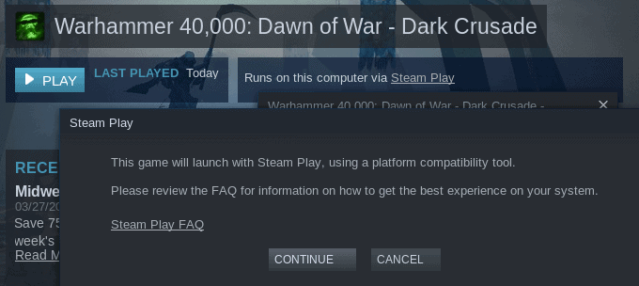
Steam Play, a feature that Valve Software launched in 2010 to allow cross-platform game play on Steam, would be used to improve support. Originally launched as a way for gamers to play their games on all platforms without having to purchase games for each platform, Valve Software included a modified version of Wine, called Proton, in Steam Play.
Proton improved compatibility and Linux users on Steam had access to more games using the new feature.
Mike published a guide in 2020 in which he described how Linux gamers could play AAA games designed for Windows on their Linux machines using Proton.
The independent database protondb keeps track of compatibility using user reports. Compatibility has improved significantly in recent years. The site highlights compatibility for the top 10, top 100 and top 1000 games on Steam.
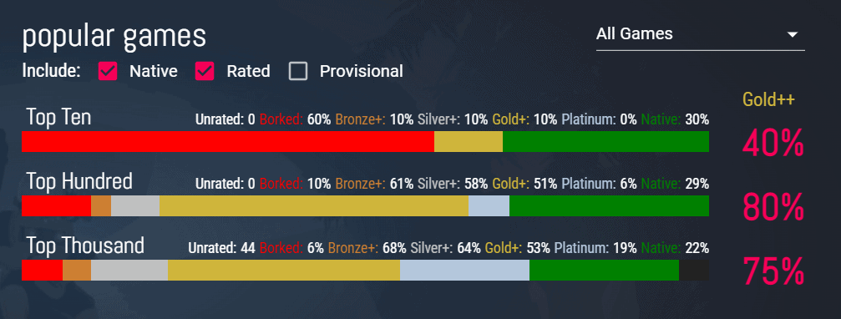
75% of the top 1000 games run on Linux now, and the figure is even higher, at 80%, for the top 100 games. Only the top 10 games are not well represented, as only 40% of them run on Linux without major issues according to the database.
Users have submitted more than 150,000 reports for over 21,000 games to the site. Of these 21,000 games, more than 17,600 are working according to the site.
Games on the database are ranked using a medal system. Platinum and Gold rated games run perfectly, and silver games may have minor issues. Bronze games may crash or have serious issues.
Borked games won't work at all or are unplayable, and native Linux games are just the opposite of that.
Protondb has a search feature that Linux gamers may use to find out if games that they are interested in work well on Linux. All games that match the search term are returned, which means that you can search for entire series of games, e.g. King's Bounty, Final Fantasy or Civilization, and get all reported games and their compatibility rating returned.
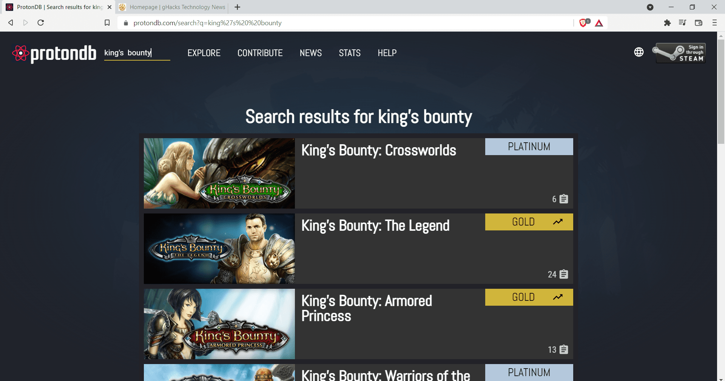
Compatibility is improving, and while there are still games that won't run on Linux, it is clear that compatibility has improved significantly in the past couple of years.
Now You: do you play games? If so, on which platforms? (via Neowin)
Summary
Article Name
75% of Steam's Top 1000 games work on Linux now
Description
75% of the top 1000 games of Valve Software's Steam Platform run well on Linux as of December 2021.
Author
Martin Brinkmann
Publisher
Ghacks Technology News
Logo


ABOUT MARTIN BRINKMANN
Martin Brinkmann is a journalist from Germany who founded Ghacks Technology News Back in 2005. He is passionate about all things tech and knows the Internet and computers like the back of his hand. You can follow Martin on Facebook or Twitter
View all posts by Martin Brinkmann →

